Our Accomplishments Are Not Our Life.
Our Life Is Our Accomplishment
(Source: The Black Belt Book of Life, topic #3)

How often in life do we get sidetracked with achieving all kinds of worldly things—name, fame, celebrity, riches, power, status, lands, titles, properties and on and on? The list of things we set out to accomplish in this life is endless, but the germane issue is that all worldly attainments are exactly that, worldly. Sound a little esoteric? Perhaps, but it's true.

Life is energy. It can neither be created nor destroyed. When the intrinsic energy that is "us" is separated from its physical form, that energy will go on. The physical body will not. So of what value are all the worldly accomplishments that enslave us? We can't take anything of this world with us when we go except our spirit and its consciousness. Therefore, it is our spirit and its development that a wise man would do well to cultivate. To involve oneself in the pursuit of things associated only with this life is a waste of life and the worst of all investments.

Martial arts training principally focuses on one thing—the development of our spirit. This is arguably its greatest gift to those of us who become its students. In martial arts training we learn discipline, balance, concentration, courage, self-responsibility and practically an endless litany of spirit-based principles which become infused into every fiber of our consciousness. These gifts go with us when we depart this world because they are us, quite unlike all the worldly things and titles we normally devote our life to which are all as fleeting as a candle flame in a hurricane. In the end, these worldly treasures betray their owners, ultimately rendering them losers, not winners.

How do we measure life? Here's a thought: think of the richest person on the face of the earth. When that person dies, for all their worldly wealth, riches, fame, name, celebrity, power and authority, when it comes time for them to exhale their last breath, they will not be able to buy one . . . single . . .more . . . breath. How priceless then is one breath? The answer . . . priceless.

Given this thought, a definition of success is here offered and it is this: success in life will not be measured until the first moment after the last breath is exhaled. It is then the individual will realize how successful or unsuccessful he was in life because his spirit will either rise or fall as it moves forward to the next phase of its existence. Seldom does the spirit stay at the same level. One sobering thought to keep in mind is from a Saint of the 15th and 16th Centuries named Guru Nanak who said, “Ranks of this world will not be recognized in the next.”
Therefore, place a high value on your training as a martial artist. It is not a waste of time. In fact, it is an extremely wise expenditure of time, effort and energy. Look deeply into what you are really learning. Is it simply how to defend yourself? How to beat someone up? A method to stay in shape, to commingle with others, to socialize? Or does martial arts training offer greater gifts than those normally perceived? Even if you achieve the coveted rank of Black Belt through a worthy system, is that in itself just a worldly accomplishment? Frankly, no, for reasons stated above. Whether we are martial artists or not, the main thing to remember is that “Our accomplishments are not our life; our life is our accomplishment.”

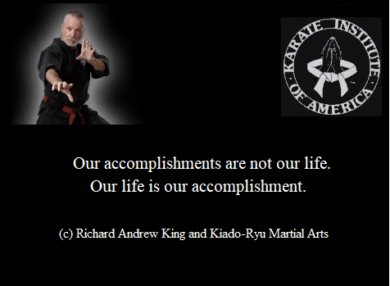

ATTAINMENT
© Richard Andrew King

As we progress and seek success
in its full embodied raiment,
Accomplishments are not our life,
our Life is our Attainment.

Possessions will not follow us
when we move beyond the grave.
Monies will be left behind
in the banks where they were saved.

Accolades and laurels
may, with some history, rest,
but none of these material things
will help us pass the Test.

Therefore, we should cogitate
on how our time is spent, for our
“Accomplishments are not our life,
our Life is our Attainment.”

How we live from day to day
at the center of our core,
is highly more important
than the things with which we score.

Ethics, morals, honesty,
purity, love and trust,
although not greatly popular,
are the things which go with us

when we move beyond this life
and the shadow of the veil,
for they will be the substance
of our life, its times and tale.

And they will be the basis
of the Judgment God will make
when He outlines the blueprint
of the future path we take.

Thus, prudent it would be to know
in quest of the Ascent,
“Accomplishments are not our life,
our Life is our Attainment.”
----------------------------------------
~finis
© Richard Andrew King & Kiado-Ryu Martial Arts

