WOMEN, GUNS & POWER

I prefer dangerous freedom over peaceful slavery.
Thomas Jefferson
3rd President of the United States of America
Primary author of the Declaration of Independence

SAFETY. SECURITY. PROTECTION. This is the core and crux of using a firearm for everyone, especially for women, who are naturally more vulnerable than males.

America is transiting the most dangerous era in its 247 year history. We’re all witnessing how bad guys are going free while law-abiding citizens are being incarcerated. It’s madness—the absolute manifestation of an upside-down, inside-out world.

A recent survey conducted by professors at Harvard and Northeastern Universities found the number of female first-time gun buyers has doubled over the past two years to 3.5 million.
(Max Diekneite--https://www.wtoc.com). That’s a lot of guns—self-defense weapons that generate safety, security and protection for their owners, especially females.

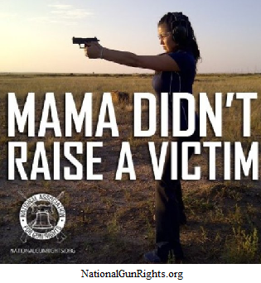

Rapes, robberies, assaults and murders are vaulting upwards. Marc Rudov (author of Intrabranding; Newsmax TV, 14 April 2023) states:

“All the gun shootings are in gun-free zones. All the Democratic
run cities in the country are over-ridden with crime and the
mayors do nothing about it.”

Therefore, sans protective action for the safety of its citizens by many of its so-called “leaders,” Americans are executing their constitutional right to protect themselves. If the government won’t do it—which they took an oath to do but violated it anyway—then the rank and file masses must take charge of their welfare and wellbeing, and that’s what’s happening.

Max Diekneite of WTOC.com shares these facts . . . (https://www.wtoc.com/2022/02/24/gun-sales-surge-among-women-certain-minority-groups/)

“The FBI tracks gun sales in the U.S. In 2019, roughly 14 million guns were sold nationwide.
In 2020, that number jumped to nearly 23 million. Another roughly 20 million guns were sold last year.” People don’t buy guns when they feel safe. They buy guns when they don’t.

A separate survey by the National Shooting Sports Foundation found gun sales went up 56% for Black Americans in 2020. Philip Smith, the President and founder of the National African American Gun Association—or NAGA—said more people in the Black community are starting to come around on lawful gun ownership. (https://www.nssf.org/articles/gun-sales-reach-record-highs-in-2020-especially-among-african-americans-and-first-time-gun-buyers/).

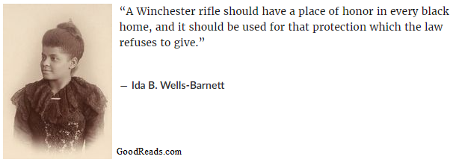

The sad reality is that the despicable condition of lawlessness in America—conditions created by atrocious and incompetent leadership and management—has forced its citizens to exercise their God-given right to protect themselves via the 2nd Amendment of the U.S. Constitution. Guns are part of that protection.

If the citizenry of America does not take appropriate action to protect itself and its freedom, the result will be enslavement by its current, corrupt, vacuous and lawless rulership. Tyrants always move to disarm their citizens so those citizens can’t protect themselves and, thus, they become slaves because they have no way to fight back. Hitler did it and so have others, i.e., China, Russia and North Korea, just to name a few.

Sadly, the current Biden administration of the United States would like to do the same—divest its people of their weapons and the protection they afford. However, Americans love their freedom and simply won’t put up with such horrific malfeasance. That’s why gun sales have been sky-rocketing. America is, truly, the “land of the free and the home of the brave” and its people will never tolerate the abuse of power forced on Lady Liberty by power-hungry incompetence and incompetents.

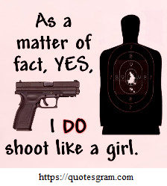

The Karate Institute of America exists to educate its students (male and female) in the art of self-defense. Firearms are simply one more piece of the protection puzzle—another layer designed to save one’s life and the lives of those they love. Unapologetically, the KIA supports responsible gun ownership and encourages all responsible individuals—men and women alike—to purchase a firearm(s) and learn to use it wisely for self and familial protection. After all, it is Our Life, Our Responsibility. Do we want others to take care of us or will we do what has to be done to secure our survival as free people?

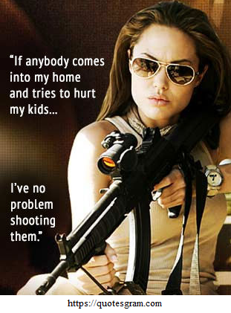

To reiterate the famous words of Thomas Jefferson . . .

I prefer dangerous freedom over peaceful slavery.

What do you choose—freedom or slavery?

~finis
(c) Richard Andrew King and Kiado-Ryu Martial Arts

