A HOLLYWOOD SKULL

In the early years of the Karate Institute of America^{tm} his callsign was “Hollywood.” A champion fighter, he ignited fear in the mind and psyche of his opponents. He could kick you in the head just as easily as punching you in the gut. In a phrase, he was “one bad dude!” Not only was he a great competitor, he was flamboyant and exciting to watch in his patriotic red, white and blue karate gi. “He” is Guy McDonald, callsign “Hollywood.”

As we all know, times change for all of us. After injuring his back in a non-karate accident, Guy’s desire to earn his Black Belt in the Kiado-Ryu^{tm} system came to an end. That was then. Now is a different time. However, the desire to excel and become one of the elite Kiado-Ryu^{tm} faithful to be placed on “The Wall” never died. With time and circumstances allowing, Guy returned to the KIA to finish his quest to become an excellent martial artist—specifically, to become a Karate Institute of America^{tm} Black Belt and join the current 64 Black Belts who made it to the apex of KIA supremacy. Those well-deserved, exemplary souls—their names, callsigns and The Wall—are here: http://www.kiado-ryu.com/black-belts/

The road back has not been easy for Hollywood. Yet, Guy McDonald, flamboyant fighter and determined martial artist, pressed on in spite of developing brain cancer, which left him with only 75% of his brain. The cancerous 25% was surgically removed from the front right part of his brain. “Hollywood” didn’t seem appropriate in this aspect of his journey so he changed his callsign to “Skull” — a fitting nom-de-guerre which added to his mystique as a fighter and martial artist. After all, would you rather fight a guy named Hollywood or a dude named Skull? Easy choice!

When his destiny moved Skull away from the KIA, he was a First Degree Brown Belt. With hard work, dedication and unrelenting determination, he is close to testing for his Second Degree Brown Belt. It will be a worthy milestone for him, as it has been for others. Therefore, keep an eye out. Skull will be placing two tabs on his Brown Belt in the not too distant future.

Following are a couple photos of Skull as he prepares himself to reach another KIA milestone. The dude is still as scary as he ever was. The black gi and shades are a nice touch—very cool.

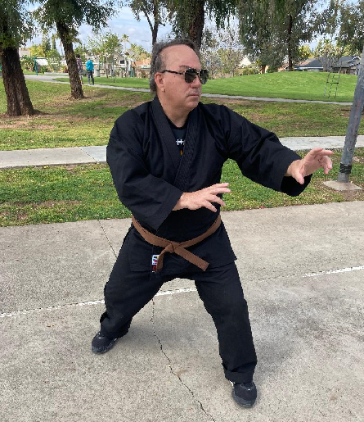

In this pic, Skull is using pvc piping as a “jo.” It’s a great martial arts tool. Try it. You’ll like it.

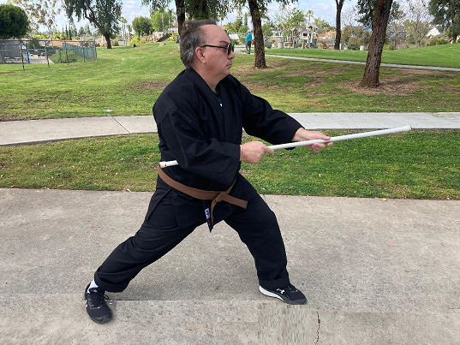

Thanks for your courage and commitment, Skull. You’re an inspiration, and everyone on this planet would be a better person if they had 1/5th of your strength, fortitude and perseverance!

~finis

(c) Richard Andrew King and Kiado-Ryu^{tm} Martial Arts.

