TIME TO SECURE

In war the first thing you must do is secure yourself against defeat.
~ Sun Tzu

Martial Arts teaches us to always be prepared to defend ourselves against an attack. It does, of course, have other benefits but survival is its most critical quality.

Some people may consider preparation to be paranoia. Nonsense. Preparation is not paranoia. It’s common sense. Obviously, we do not live in a loving, peaceful, harmonious world. Rather, we live in an inharmonious world—one existing in a perpetual state of opposition, struggle and conflict. Ignoring this fact makes us foolish. Embracing it makes us wise.

Each of us is responsible for our own safety and well-being. As the Kiado-Ryu system of martial arts teaches, this is “Our Life, Our Responsibility.” Looking to others for safety and security is not a smart strategy of survival. Sadly, this thought of looking to others for our safety is too commonplace in today’s world. Each of us and our families must always be ready for the worst while doing and praying for the best.

To add to Sun Tzu’s quote above, the Kiado-Ryu system of martial arts pronounces . . .

In life, as in war, the first thing we must do is secure ourselves against defeat.

Arguably, the volatile world of today is as close to exploding as it ever has been. Those who lived through the Cuban Missile Crisis of October 1962 understand the problem, as the world was seriously close to nuclear war between the USSR and the United States. Now, in 2023, it feels like that all over again but with an addition of bad actors in the leadership positions of China, Russia, North Korea and Iran. One misstep and the entire globe could go up in flames. Much of this disaster is a result of America’s policy of appeasement posited by feckless, fragile and failed United States leadership. Appeasement is a real, weak, ignorant and dangerous policy inviting others to attack and ultimately destroy them i.e., the appeasers.

This is not even to mention the political, social, moral, ethical, polarization and degradation of America both internally and externally.

Given this sad reality, NOW is the TIME TO SECURE ourselves and our families against the possibility of conflict, disruption and turmoil. Why wait? Common Sense and wisdom proclaim, “Get it done NOW!”

And remember what happened when COVID 19 hit? It generated miles of auto-laden food lines throughout the country full of people who needed food and supplies, people who didn’t prepare for their welfare and safety. Rather, they looked to others for their security and well-being—a foolish life strategy. They were lucky they did get help and support. That was then but what happens in a future crisis if there is no calvary coming to the rescue? Talk about having a bad day, a bad decade or even worse! If a war involving the United States or our allies does occur, what happens to lines of distribution involving all aspects of supplies, food and water needed to supplant and support a vibrant and positive existence? And what about lines of communication? Lines of commerce? Lines of medical support? What then? Remember, not too long ago, when store shelves were bare of food and common supplies; when ships could not get their merchandise into port but were parked off the coast in massive numbers? Another, but more perilous and tumultuous event, would be a catastrophic nightmare of nightmares.

Just a visual reminder . . .

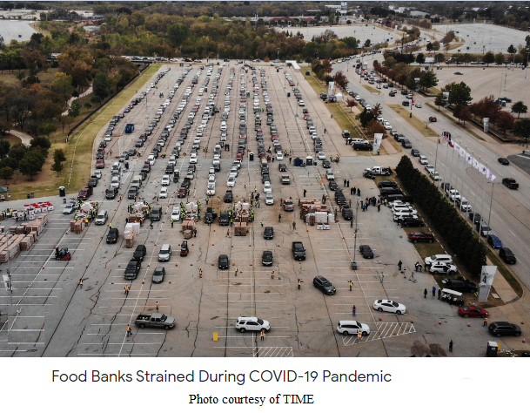


We cannot force people to do the obvious as far as self-defense is concerned. However, we can take action in getting ourselves and our families prepared for potential conflict and turmoil. There is no logical reason not to do so. What is there to lose? As the following two quotes remind us . . .

It's better to be safe than sorry
and
If we fail to prepare, we prepare to fail.

And to this article’s point . . .

In life, as in war, the first thing we must do is secure ourselves against defeat.

Given the global climate of today and the tumult in the United States, wisdom tells us to prepare. Ignorance tells us to do nothing. The point of view of the Karate Institute of America and the Kiado-Ryu system of martial arts is the former. God help those who choose the latter.

~finis

(c) Richard Andrew King and Kiado-Ryu.com.

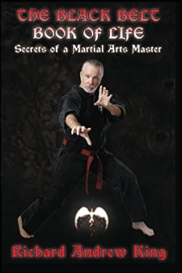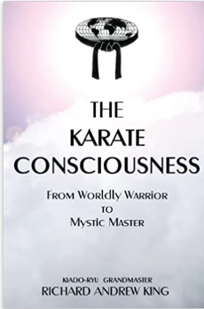
Available at RichardKing.net/books & Amazon.com

