R.I.P. ROGER GRIFFIN
PATRIARCH—GRIFFIN FAMILY

Thursday, June 1st., my beloved father, Roger Griffin, passed from this life to Eternity in the presence of his Lord Jesus Christ. ~ James "Psycho" Griffin

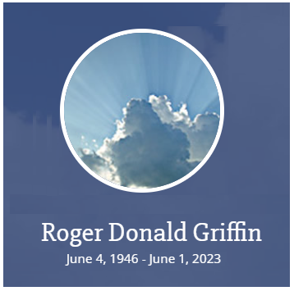

It is a sad occasion to share such news. Roger Griffin passed away on 1 June 2023, in Sandpoint, Idaho. He will be sorely missed. Mr. Griffin and Mrs. AviceMarie Griffin raised four sons—Joel, Josh, James and Ben— and one daughter, Anastasia. In fact, two Griffin family members became KIA Black Belts: James, aka "Psycho" (Kiado-Ryu Black Belt #60: 7 September 2000) and Anastasia, aka "Wildcat" (Kiado-Ryu Black Belt #55: 25 April 1998).The entire Griffin family has always been supernal human beings—God centered, positive, generous, kind, accomplished, patriotic and an undeniable tribute to their friends and community.

It is not hyperbole to say that the Griffins were, and still are, great supporters of the Karate Institute of America and the Kiado-Ryu System of Martial Arts, and have been for decades. All of us at the KIA are extremely enriched to have known Mr. Griffin. There is no question he was a First Class gift to everyone he touched. He will be sorely missed but never forgotten. His legacy will remain framed in gold forever.



One of the greatest attributes of Mr. Griffin was his humility, especially given his educational and professional background (see the Linkedin link "About" below). He was an extremely unique individual, kind to all; enemy to none. He, as well as his wife and children, are all stellar examples of what it is to be human.

Linkedin: About
https://www.linkedin.com/in/roger-griffin-2b24b728/

Experienced Director with a demonstrated history of working in the environmental services industry. Skilled in Executive operations, Negotiation, Waste management, Business Planning, Environmental Issues, and Entrepreneurship. Strong professional with a MS-Engineering focused from University of California, Irvine and a licensed engineer in three western states.

It is such an honor for me personally to have been photographed with Mr. Griffin and son, James. That smile on Mr. Griffin's face is as genuine as they come.

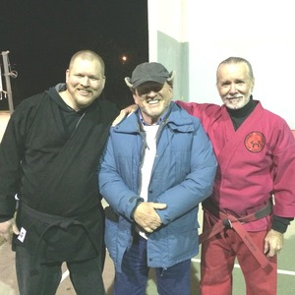
Roger Griffin with James "Psycho" Griffin
and Mr. King—11 January 2016

ROGER'S OBITUARY
https://www.coffeltfuneral.com/obituary/roger-griffin

Roger Donald Griffin was born to military parents Theodore and Lucille Griffin in Camp Lejeune, N. Carolina, and spent his first several years in Cuba, where his dad was stationed after World War 2. Their next major stop was Corpus Christi, Texas for several years, with a final posting in Oceanside, Ca. where Roger finished high school and began college. He never lost touch with his relatives either in Eads, Colorado where his mother was raised, or Tennessee, where his paternal cousins lived. In fact, he received letters and photos from three cousins about a week before he passed. His high school interests were science, photography, football, and motorcycles, carrying these interests into college.
Then he met the Lord Jesus Christ, and his life began to change. He loved to travel; he took his first major trip to Australia to visit a close friend who had moved there. Next, he met and became best friends with his future wife who also dedicated her life to Jesus. They built their home and raised their family, active in church where Roger sang in the choir and they frequently hosted prayer meetings in their home, praying for family, friends, and frequently fasting. One of his favorite family activities was to read aloud to the children, books like Treasure Island, and The Hobbit, sometimes leading to shrieks and tears of fright as well as laughter and fun.
He worked for a government agency detecting air pollution, but eventually moved into the private sector, focusing on solving the problem of pollution. When his family was still young, he presented a paper in Paris, France, and took his family along for the holiday. This was possible financially because of a home exchange; the French family became fast and life-long friends, and met several times over the years. Professionally he became known as an expert in his field and was tapped by UCLA and UCI to teach extension courses for the next ten years. During that time he authored and published 2 books and presented numerous papers in Europe and Scandinavia.

He never stopped growing and learning. He, with all of his family, moved to this part of the country, which he loved. His third book was finished after his move to Idaho; all three are still technical best-sellers. Thus he had a real impact on the education about and the science of hazardous waste ecology. He joined the Idaho Forest Owners Association. He counted among his friends some of the greatest thinkers and proponents of Biblical Creation of our time, like Walt Brown and Mike Snavely.
His first loyalty was the the Lord Jesus Christ, next came his wife and four sons and his daughter. He was devoted to his brothers and sisters in Christ. He served the Lord in many churches, speaking the truth in love, sharing his insights, and praying with and for his brethren.

He is survived by his wife, AviceMarie, his brother Keith (Stella), his sons Joel, Joshua (Hannah), James, Benjamin (Rachel), and his daughter Anastasia, and eight grandchildren: Hannah Esther, Anna Mary, Theodore Roger, Joshua James Jr., Ezra Joel, Seth, Aaron, and Vivianne Lucille.
________________________________________________________

Thank you, Mr. Griffin, for all the loving support and inspiration you bequeathed to the KIA and the Karate Institute of America! You will always be remembered and cherished as the great human being you are. Many blessings to you in your ascent, as well as your entire family! God Speed!

~finis

(C) Richard Andrew King, the Karate Institute of America and Kiado-Ryu Martial Arts.

