TACTICS BEFORE STRATEGY IS THE
NOISE BEFORE DEFEAT
~ SUN TZU



IT IS AMAZING how many fighters—in the ring or out—seldom, if ever, thoroughly study their opponent before they engage in battle. They may watch a video or two but such a "preparation for battle" does not reflect a true, studious and serious effort to understand the opponent and accomplish the task at hand, which is to win the conflict, not simply to become a combatant in it. Warriors, true warriors, go into battle with one and only one thought—victory. Sun Tzu knew this, as did General George Patton, Sir Winston Churchill and other highly intelligent and successful warriors.

As Sun Tzu has stated, "War is a grave concern of the state. It must be thoroughly studied." Certainly, one of the main ingredients to victory is having a vice-like grip on the following quote:

TACTICS BEFORE STRATEGY IS THE NOISE BEFORE DEFEAT.

"Strategy" is defined as the all-around plan for battle. It's the big picture. "Tactics" involve a multiplicity of warcraft methodologies needed to secure victory.
Going a step further, it is absolutely amazing how many "leaders" have no clue how to engage, let alone win, a war? For example, how many United States Presidents have told America's enemies what they, the "leaders," are going to do before they "pull the trigger" so to speak, but, actually, never pull that trigger? Bluffing is not a strategy for success unless the "bluff'" is a trap or a component of the overriding strategic design.

Such an acclaim of broadcasting one's intent is stunningly ignorant, foolish and dangerous. Any American who is paying attention knows who these failed "leaders" are and have been. Their foolish actions have created a potential for World War III. Had such "leaders" studied the Art of War, they would know better but, alas, they have little to no clue regarding the fundamentals of war. Their only thought is gaining and/or maintaining political power.

Never, never, never broadcast to an enemy what you are going to do unless that "broadcast" is a ruse or ambush. Red lines only work if you back them up. Giving adversaries money in hopes of appeasing them is not only ludicrous, it is childish, weak and dangerous. The uneducated individuals who promote "tactics before strategy" will be the ones who hear the "noise" just before the hammer drops on their ignominious defeat.

For example, take football. Let's say your team has a great quarterback and excellent receivers. Therefore, your strategic plan may well be to overwhelm the opposition with a passing game. However, the opponent has a great defense against the pass. Therefore, you have to develop a tactical plan, most likely comprised of many parts, to make the strategy of your passing game effective and successful.

"Strategy before Tactics" is the correct process, not vice-versa. Sun Tzu had it right. Just ask any successful leader or, perhaps, a failed but still living leader who is smart enough and humble enough to realize his unfortunate mistake—placing tactics before strategy. If you want to win, it's "Strategy first, Tactics second." Think of the big picture (strategy) and then fill it up with smaller pictures (tactics).

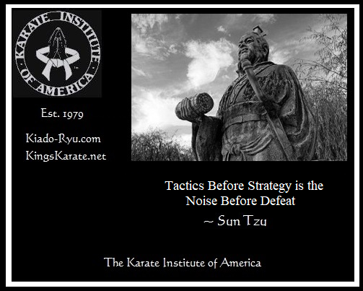

~finis

(c) Richard Andrew King and Kiado-Ryu(tm) Martial Arts


Available at RichardKing.net/books & Amazon.com
More Martial Arts info here: www.Kiado-Ryu.com and www.KingsKarate.net

