JDRF T1D CHILDREN'S CONGRESS

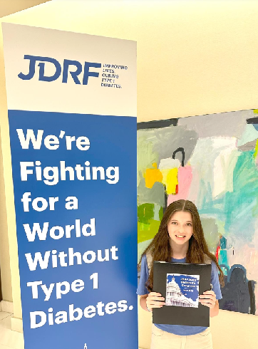
Delegate Paige Jacob at the JDRF CHILDREN'S CONGRESS,
Washington, D.C., July 2023
Juvenile Diabetes Research Foundation: https://www.jdrf.org/t1d-resources/about/

JDRF 2023 Children’s Congress Makes Waves in Washington
Published July 12, 2023 in Advocacy, Children's Congress, Special Diabetes Program
https://www.jdrf.org/blog/2023/07/12/childrens-congress-2/

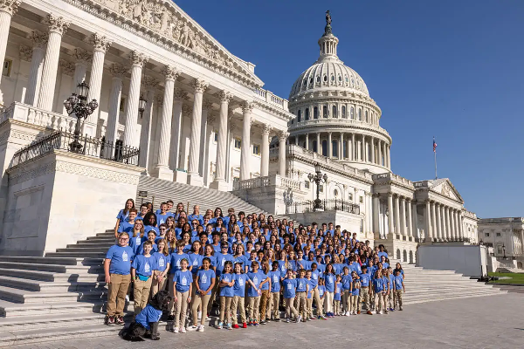

JDRF 2023 Children’s Congress is over—and it was an incredible success! It’s been a long four years since the last JDRF Children’s Congress, and the Delegates did an incredible job of making up for lost time. Delegates forged new connections, told hundreds of stories, and, as a result, we made real progress towards achieving key aspects of our Advocacy agenda.

One JDRF Children’s Congress, One Voice
Every two years, more than 160 children with type 1 diabetes (T1D) between the ages of 4 – 17 gather in Washington, D.C., to meet face-to-face with some of the top decision-makers in the U.S. Government. The selected Delegates represented nearly every state, as well as four International Affiliates. Delegates have a unique and empowering opportunity to help Members of Congress understand what life with T1D is like, while forming lasting bonds with fellow youth who live with this autoimmune disease.
The event was led by JDRF 2023 Children’s Congress Chair Natalie Stanback and her family.
The Delegates focused on two areas of JDRF’s Advocacy Agenda: Renewing the Special Diabetes Program (SDP) and the insulin affordability crisis.
The SDP currently provides $150 million annually to T1D research through the National Institutes of Health (NIH), the country’s premier medical research agency. Additionally, it complements JDRF’s research efforts, allowing JDRF and the NIH to collaborate to advance T1D research as quickly as possible. The SDP is set to expire in September and renewing it is JDRF’s biggest priority—and the #1 job for the Delegates.
Right now, there is legislation to renew the SDP for two years at $170 million annually. This would be the first annual increase in funding in 20 years.
“The SDP is vital,” said Natalie Stanback. “By spreading awareness in the halls of Congress and meeting with our lawmakers, we did all we could to ensure the research made possible by this program continues. We made sure the needs of the T1D community were heard!”
Congress also must address the cost of insulin in America. While recent measures taken by pharmaceutical companies to lower the cost of their insulins are appreciated, more must be done. That message was heard loud and clear.
Over the course of three days, Delegates traveled to Washington D.C., spent time with each other, and received training on how to advocate for these issues with their Members of Congress.

It’s A Wrap
In total, 163 Delegates, plus ten T1D Role Models, had 239 meetings with U.S. Senators and Representatives to get support for these critical issues. They did an incredible job—and were ideal representatives of the T1D Community.
These Delegates were tasked with telling their stories about life with T1D, and each of them rose to the occasion—and more. Thanks to their brave advocacy, we are on the cusp of a 2-year renewal of the Special Diabetes Program funded at $170 million per year. The first increase in annual SDP funding in 20 years is long overdue, and Congress is poised to deliver—accelerating our path the cures.

Catch Up
You can experience the highlights of JDRF 2023 Children’s Congress on our social media channels, including interviews with Delegates and celebrities, recaps from JDRF CEO Aaron Kowalski, and more. Check them out on Instagram, Twitter, Facebook, YouTube and LinkedIn.

Join Us!
While the Delegates did an amazing job convincing our legislators to renew the SDP and do more to fix the insulin affordability crisis, you can join the fight too. Sign up to be an advocate! It’s the easiest way to stay up to date and take action on advocacy issues.
This event was made possible by:
Delegate Social Sponsors Dexcom, Vertex, and Xeris Pharmaceuticals
Supporting Sponsors Insulet and Lilly
Diamond One Society Partnership Sponsors Ford and Marshalls

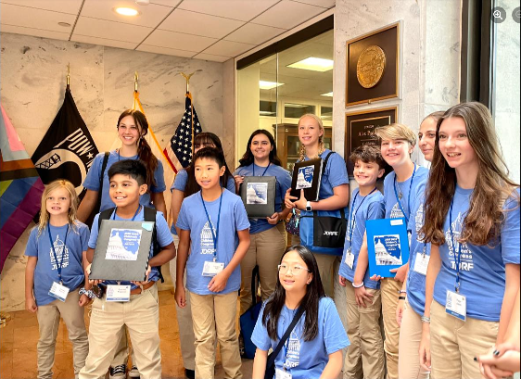

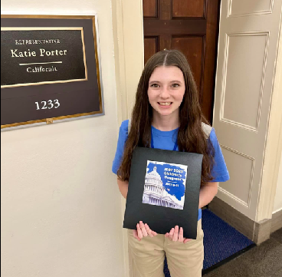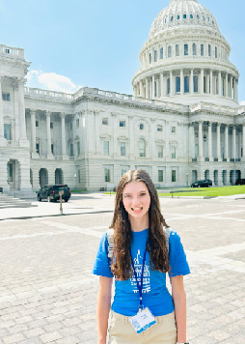

T1D Delegate Paige Jacob with proud mom Christa Jacob (King)

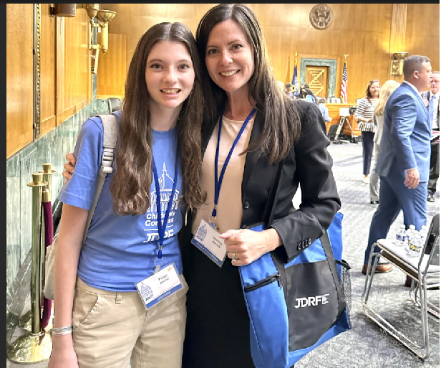

In Christa's words . . .

Words cannot describe our experience last week. Paige had the honor of joining 160+ kids and teenagers in Washington, D.C., for the JDRF 2023 Children's Congress. These incredible delegates met with Congress to raise awareness for T1D and advocate for affordable insulin and renewal of the Special Diabetes Program, which provides critical funding for T1D research.

It was an unforgettable 3 days filled with new friends, lifelong memories, inspiring messages, and powerful lessons of using your voice and creating change for a greater purpose. We leave D.C. with full hearts, deeper gratitude for JDRF and this amazing community, and greater determination to continue our mission until there's a cure.

~finis

(c) Richard Andrew King and Kiado-Ryu(tm) Martial Arts


Available at RichardKing.net/books & Amazon.com
More Martial Arts info here: www.Kiado-Ryu.com and www.KingsKarate.net

