CONGRATULATIONS ARIAN!

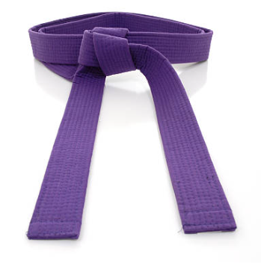

The 9th of September 2023 was a great day for Arian D, aka "Terror." Not only was it his 11th birthday—complete with an afternoon birthday party—it was also his KIA Purple Belt test day in which he passed with glorious success! So ... here's to you, young man: CONGRATULATIONS on your achievement of becoming a Kiado-Ryu^{tm} Purple Belt!

Remember this pic when Arian was awarded his Orange Belt back in June of 2022?

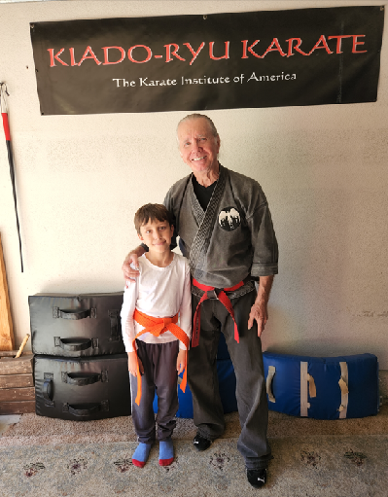

Well, look at him now just a few days before his Purple Belt test! What a change in 14 months!

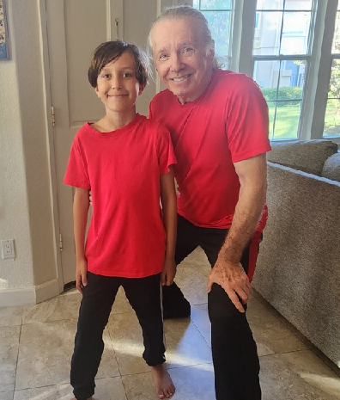

Arian is a great kid. He is very smart, easy to teach—because he's such a wonderful student—and fun to be around. Did I mention he's smart? Well, in case I missed mentioning it, he is. He has an excellent memory, too—one of the best in Kiado-Ryu(^{tm)} history. For example, can you name the Seven Modes of Motion? Not only can Arian run them off in a whiz, he can explain why each of the Seven Modes of Motion is important! It's awesome to see.

Terror's test began with a two minute Still Stance (he had already passed the ten minute version for his Purple belt rank) to show friends and family how disciplined KIA students must be to manifest a calm and centered presence within themselves.

Next, Arian demonstrated a wide variety of martial arts skills including "Bob Work" with open hands, fists, armbars, knee strikes and kicks—all in one minute timed drills. His kata performance was nicely done, as was "Foot Set" in three different speeds. Also highlighted were Change and Quick Change drills and Ground defense. Even push ups were on the menu.

The most exciting event during Arian's test was his fighting! He was shoving old Mr. King around every which way, faking him out in an onslaught of punches from all kinds of directions and angles. Talk about being a "Terror," Terror was definitely that. It is scary what this eleven year old young man is going to be when he fully matures. He'll be KIA disciplined and self-controlled, of course, but he will definitely not be someone to mess with.

In the following pic Arian ducks one of Mr. King's roundhouse punches as he hits the old guy with an uppercut punch to the ribs. Ouch!

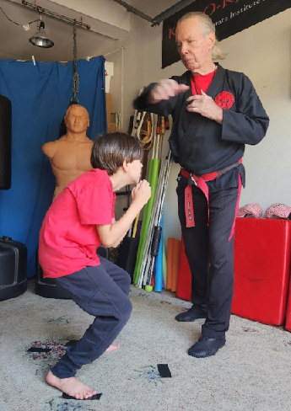

The following photo is the normal bow of respect after a job well done!

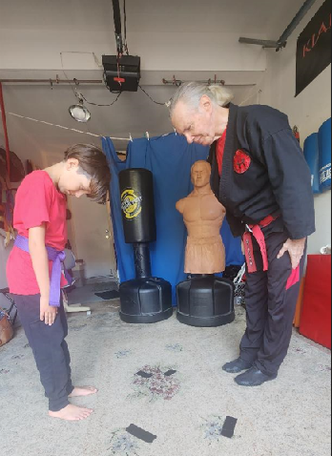

Finally, the handshake with his beautiful Purple Belt symbol of achievement tied around his waist.

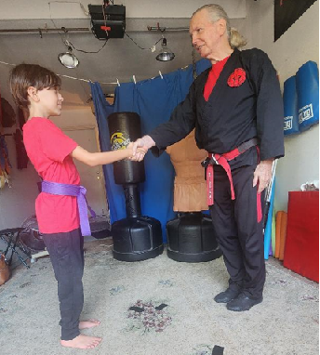

Thanks, Arian, for the excellent show of your talent, skill, character and respectful demeanor.
It's going to be even more fun as you rise to the Blue Belt level, so carry on, young man! The
best is yet to come!

(c) Richard Andrew King and Kiado-Ryu(^{tm)} Martial Arts

