HAWK SOARS TO BLACK!

The business world knows him as David T. "Chip" Robinson, Jr., President of THE MANAGEMENT WORKS, INC., Newport Beach, CA. However, the Karate Institute of America^{tm} knows him by only one name — his callsign — "Hawk!"

Hawk began his martial arts journey at sixteen years of age. His first championship was at the Orange Belt level—the first color belt above White, the color for beginners.

Obviously, winning his first championship as an Orange Belt was a portent of things to come, and oh how they came! Hawk became an extraordinary competitor at every level through 3rd Degree Brown Belt. No other Kiado-Ryu^{tm} student in KIA history has won more combined Fighting and Forms (kata) championships than the Hawk! After all, hawks are predators. They delight in overwhelming their prey, and my-oh-my how Hawk reveled in not just overwhelming his prey but overpowering his prey!

Destiny, however, put a stop to Hawk's martial arts ambitions, at least for the moment. In his early twenties life changed for this extraordinary martial arts competitor. College, marriage, children and a budding business career moved Hawk away from the lights of karate competition—for decades. That
all changed, however, in his early fifties when destiny pulled him back into the world of martial arts and specifically to the Karate Institute of America^{tm} and the Kiado-Ryu^{tm} system where his journey began.

The thing that kept driving Hawk through decades of basic life events and experiences was his desire to ultimately achieve a Kiado-Ryu^{tm} Black Belt—a coveted title that only 64 aspirants out of over 3,300 students have reached in the forty-four year history of the KIA. That's less than 2%. To be a Kiado-Ryu^{tm} Black Belt demands dedication, determination, desire, discipline, commitment, courage, constancy and a will that hungers to succeed. Hawk is a manifestation of that hunger, just like those KIA Black Belts who preceded him—those who are memorialized and honored for their accomplishment by having their names and ranks eternally placed on THE WALL (https://www.kiado-ryu.com/black-belts/).

On Wednesday, 13 September 2023, David T. "Chip" Robinson, Jr.—aka Hawk—became the 65th Black Belt of the Karate Institute of America^{tm} and the Kiado-Ryu^{tm} system of martial arts.

CONGRATULATIONS, HAWK! Welcome to the club! You certainly deserve it!

Following are some recent photos representing Hawk's journey to the coveted KIA rank of Black Belt.

THE STILL STANCE
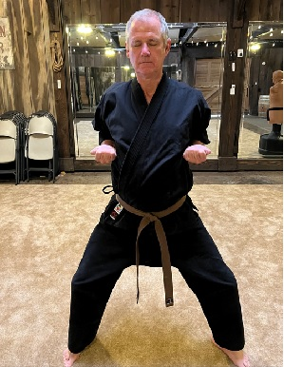

Above: The one hour Still Stance is a major requirement of all KIA Black Belts. It is designed to develop discipline, self-control, strength and command of one's self. Any movement results in disqualification. Of course, this is everyone's favorite aspect of their Black Belt test (yeah, right).

Below: Hawk demonstrating a kata illustrating his championship form.

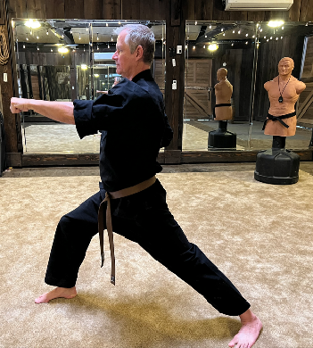
HAND & WEAPONS WORK

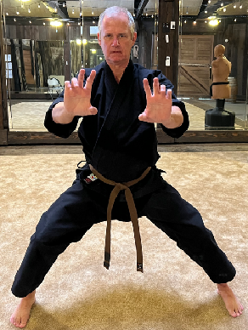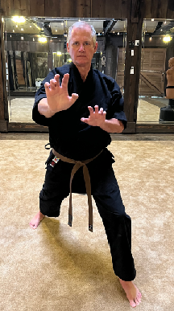

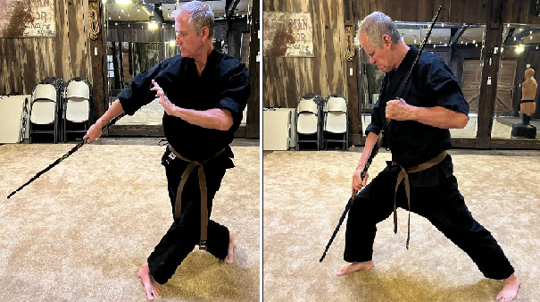

Cane work on "Bob" (the dummy)

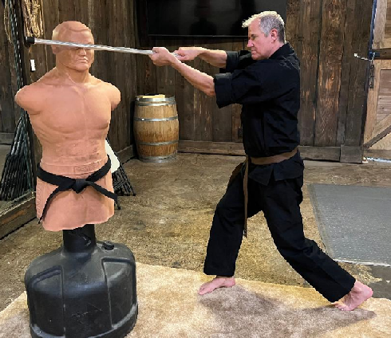

And a little fun, sort of! Remember the younger days when . . .?

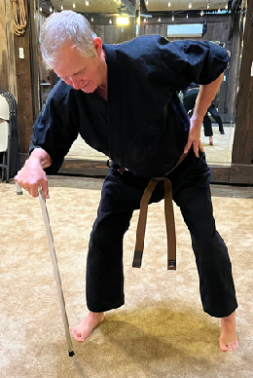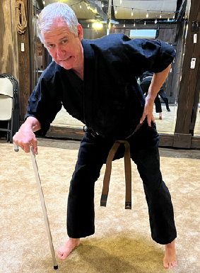

THE PRIZE

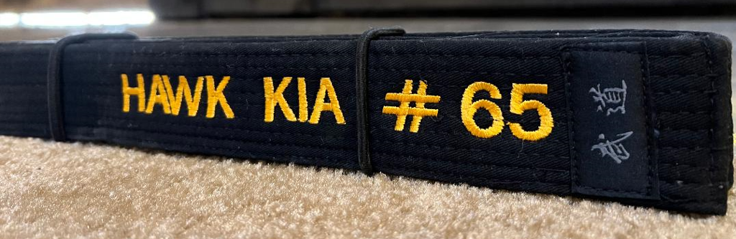

Every Kiado-Ryu Black Belt receives their belt embroidered with their name and number. It is the "Prize" signifying their accomplishment. It is one of a kind . . . forever! Hawk's KIA Black Belt honors him as the 65th Black Belt of the Karate Institute of America^{tm}.

The emotions of receiving one's Black Belt are unfathomable to everyone except the KIA few.
The moment of paying respect and admiration of the final act of the journey is Inexplicable.

No other photograph can come close to expressing the meaning and exultation of this occasion.

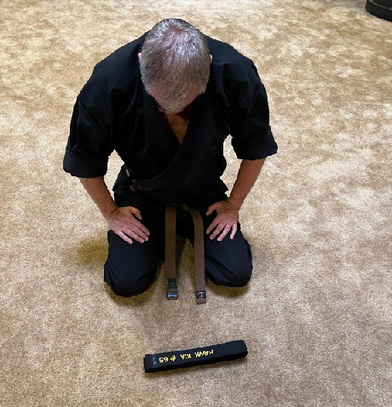

A playful and joyful post test moment with Bob.
The smile tells it all!

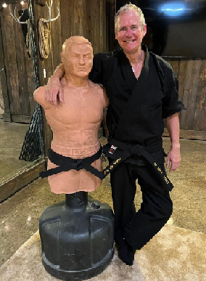

Shared happiness for a job well done!

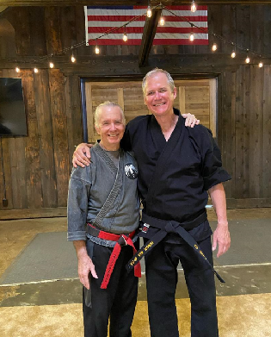

And . . . as in all great stories, the HAWK soars upward
to greater heights with his gorgeous better half, Jen Wild.
To be continued!

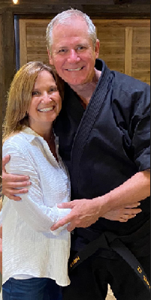

(c) Richard Andrew King
The Karate Institute of America^{tm} and Kiado-Ryu^{tm} Martial Arts.

