SHOOTOUT AT COOK'S CORNER
Trabuco Canyon, Orange County, CA
23 August 2023, Wednesday
(21:34—Actual Sheriff Body Cam footage at the link below)
_________________________________________________________________

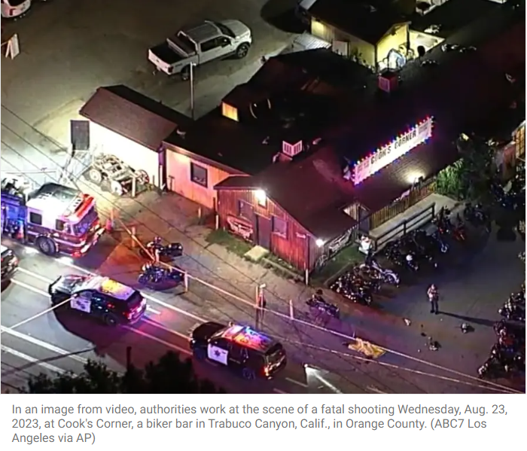

Miranda Ceja, Patch Staff: Posted Fri, Oct 6, 2023 at 12:09 pm PT | Updated Fri, Oct 6, 2023 at 1:48 pm PT

GOOD DAY LA news story (5:42) here: https://www.youtube.com/watch?v=Fa2mM6FeU-8
KTLA 5 news story: (3:25) here: https://www.youtube.com/watch?v=gPZ1Oh9UEt4
ABC 7 news story: (3:57) here: https://www.youtube.com/watch?v=fQXqk6DZ5bU
Los Angeles Times: (2:22) here: https://www.youtube.com/watch?v=k3A-DC1hoCQ
______________________________________________________________________________

It wasn't a gunfight at the OK Corral (https://www.ok-corral.com/pages/history.shtml) but it was deadly. A lone shooter, retired sheriff John Snowling, shot his wife in the face and killed three innocent people at famous Cooks Corner—a family restaurant in Trabuco Canyon, Orange County, CA. The dead were identified as Tonya Clark, 49, of Scottsdale, Arizona; Glen Sprowl Jr., 53, of Stanton and John Leehey, 67, of Irvine. Snowling, whose motive apparently had to do with his wife's filing for divorce, was killed in the massive gunfight.

A 21:34 Sheriff's video of the shootout is here: https://youtu.be/QLtm7FfAgmM. It's worth the watch. This shooting was not a Hollywood movie. It was 100% authentic, offering a true view of reality, not fantasy. There's a lot to learn from this video, especially how brave and deserving of praise the men and women of law enforcement are. Viewer advised content. Condolences to the families of the victims.

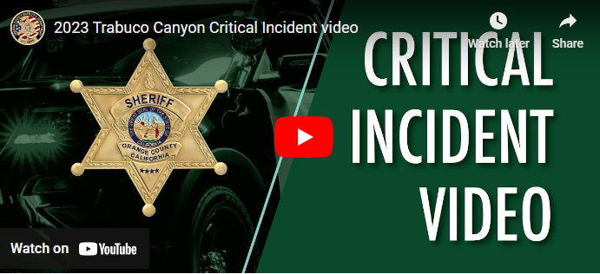

~finis

(c) Richard Andrew King and Kiado-Ryu Martial Arts

