ELITE MEANS ELITE!

In an ever-growing and hostile environment due to a law and order breakdown, millions of Americans are exercising their 2nd Amendment right to carry a firearm for their personal protection. Different states have different laws regarding carrying a firearm. In California, the legal right to do so falls into a category identified as ”CCW” or “Concealed Carry Weapon.”

One of the businesses offering CCW services and firearm training in Orange County is ELITECCW (www.eliteccw.com) located at 18183 Euclid Street, Fountain Valley, CA, 92708.
Although many firearm services exist in SoCal, Eliteccw.com is unique in multiple ways.

First, Elite.com is a Father/Son enterprise. Smart move. Keeping things in the family can certainly be a positive business decision. Meet the owners: Mike (right) and Bailey (left) Duda!

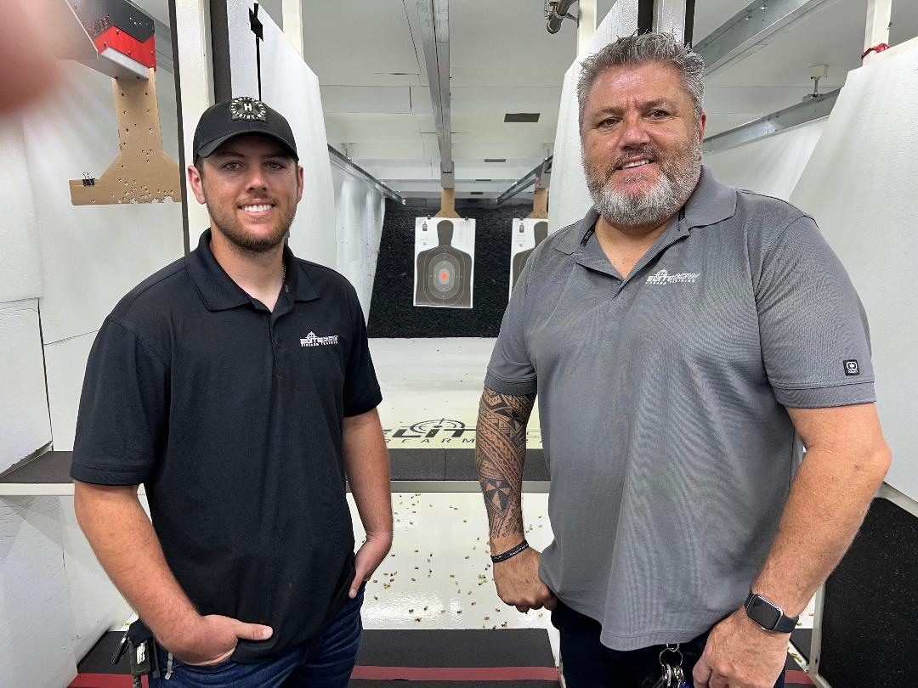

These two men are quite elite in themselves. Mike, Founder of Elite.com, has an extensive and powerful set of credentials. He served in Law Enforcement for 22 years in Orange County in multiple divisions; was a member in the U.S. Army for 12 years, rising to E-7 Sergeant First Class. Mike was a Tank Commander (General George Patton would be proud!). He served in Desert Shield and is a Storm War Veteran and . . . a Silver Star recipient! And these are just a few of his credentials! Read his full bio here: https://www.eliteccw.com/about-us/. The Karate Institute of America has, with Mike’s permission, given him the callsign, “Tank!” Simply obvious—the man is a beast! He is also an American patriot. God help our enemies!
No less impressive is son, Bailey Duda—Eliteccw.com’s Senior Operations Manager. He is also a National Rifle Association Certified Instructor; a Certified Range Safety Officer; a Certified Glock Armorer; a Certified Sig Sauer Armorer and a Competition Level shooter in handguns. Bailey started learning to shoot at age six and currently has over twenty years of shooting experience behind him. Having been trained by the “Best Instructor Ever” (guess who?), Baily also is active in a multitude of other aspects in running the business. Father and son—such a great combo! Bailey’s bio is here: https://www.eliteccw.com/about-us/

Many of the services EliteCCW offers are: In person CCW classes, Range classes, Basic Pistol classes, Live Fire and Simulator training, Special events and Group classes.

Bailey and the Karate Institute of America’s most recent Black Belt, Chip “Hawk” Robinson, pose together in one of EliteCCW’s training rooms, specifically, the Simulator room.

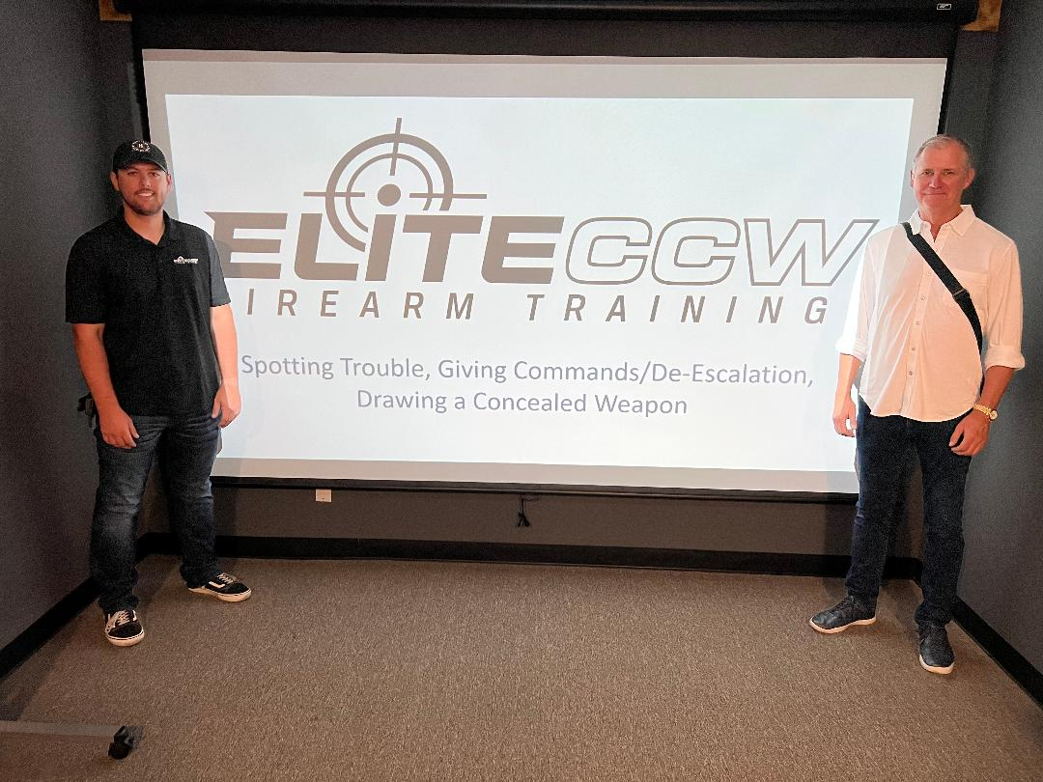

Hawk, Bailey and Mr. King in one of the hallways leading to yet another training room.
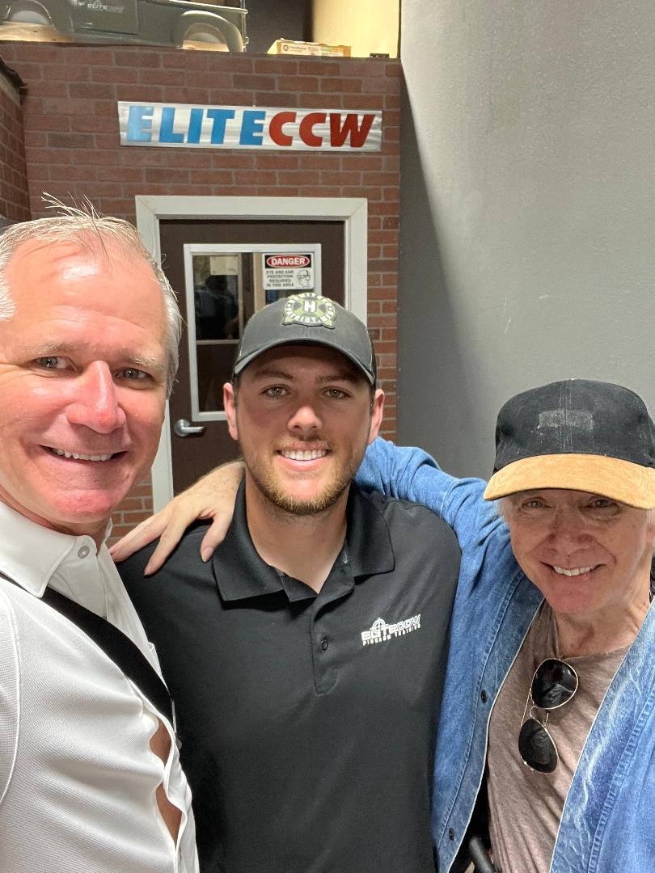

EliteCCW.com is truly elite. Mike and Bailey have created an excellent facility for anyone wishing to learn and become efficient in the use of firearms. If you’re looking for a truly elite organization and business to further your skill, expertise and confidence, the Karate Institute of America, Kiado-Ryu.com and KingsKarate.net confidently recommend EliteCCW.com!

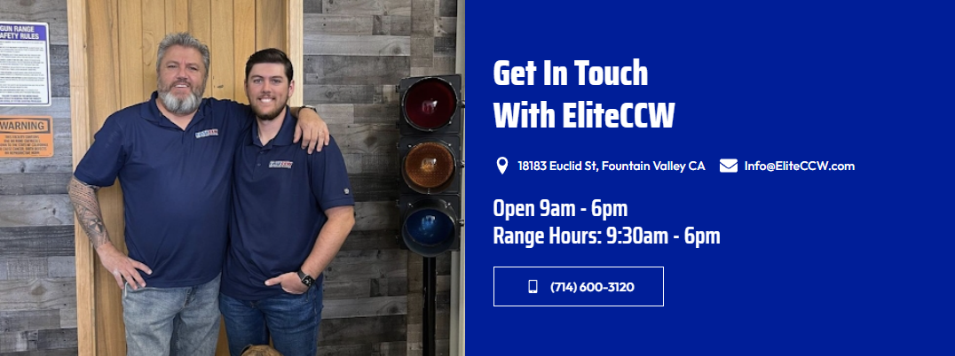

Thanks, Gentlemen, for giving us the tour of your excellent facility, as well as Bailey’s great teaching tips! He’s a great instructor, truly Elite!

We wish you all the best. We’ll be back, for sure!

~finis

© The Karate Institute of America, Kiado-Ryu.com and KingsKarate.net.

