SKULL RISING!
ATTAINS 2ND DEGREE BROWN BELT

It was Wednesday, 25 October 2023, that a major accomplishment occurred at the Karate Institute of America. Guy McDonald, aka “Skull,” achieved his 2nd Degree Brown Belt ranking. This was a big deal, bigger than most Kiado-Ryu belt acknowledgements. It was also unique—a inspirational feat never before occurring in KIA history. Skull should be extremely proud of his accomplishment, as well as his entire family. CONGRATULATIONS, GUY!

Why, you may ask, was Skull’s accomplishment so unique, so different, so deserving of merit? Answer: because Guy McDonald was working with only 75% of his brain, literally. In other words, 25% of his brain was missing. This was due to his fight with brain cancer. Guy credits Dr. Anthony Kim of Mission Hospital for saving his life and refers to him as his godsend.

Skull began his KIA journey at 17 years of age in the 1980s. He’s now 57. Back in the “day” Guy’s nickname was “Hollywood” because of his artistic and showmanship nature. Always adorned in a red, white and blue Stars and Stripes gi (uniform), Hollywood was a stunning performer and one of the Karate Institute of America’s best championship fighters. His opponents especially had to be aware of his roundhouse kick to the head—one of his favorite well honed skills.

Unrelated to martial arts, a severe back injury in the mid 1990s diverted Hollywood from the KIA and his dream to be a Kiado-Ryu Black Belt. Then, to make matters worse, Guy developed brain cancer. Fortunately, Dr. Kim saved his life. Finally, in his mid 50s Guy rediscovered his desire to earn a KIA Black Belt and since “Hollywood” no longer seemed appropriate, he changed his callsign to “Skull,” which is perfectly appropriate, and quite cool, to be sure!

Earning a 2nd Degree KIA Brown Belt is no easy task—even when someone is in great shape. Yet, Skull, with 25% of his brain gone, was determined to press on. His determination, courage, fortitude and desire have all served him well and highlighted what people can do if they locked themselves into the unrelenting mode and mindset of, “I’m going to earn my Black Belt!”

Guy McDonald is an inspiration and there is absolutely no doubt he will achieve the vaunted KIA Black Belt status. It’s just a matter of keeping on, keeping on and . . . never giving up!

Not all of Guy’s family could make it to his 2nd Brown Belt test, even though they would have liked to do so. In the following photo, those in attendance from left to right are: dad James; his wife Suzi; Skull and his wife Deirdre, and one of the U.S. Marine Corps finest—Lance Corporal Will Robertson, who is dating the McDonald’s daughter, Delaney.

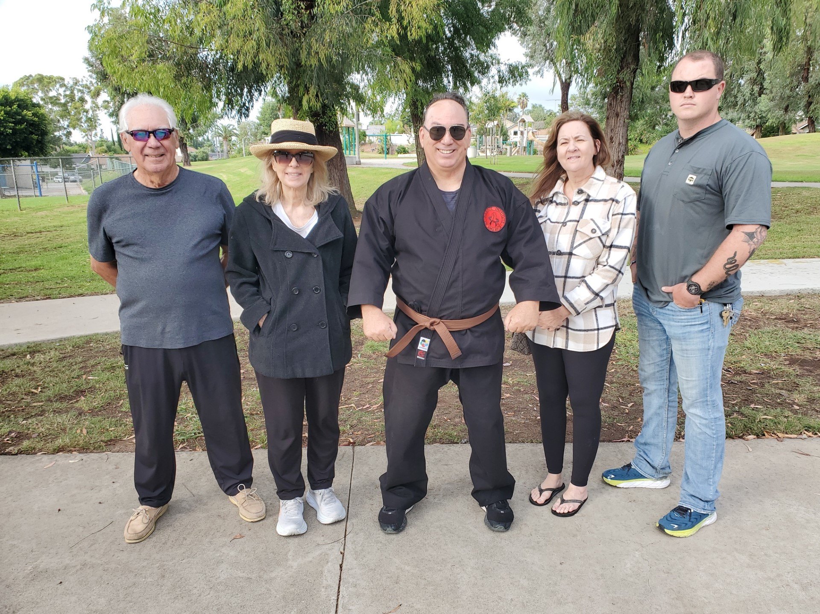

A Special note of gratitude.

Lance Corporal Will Robertson gifted the Karate Institute of America a U.S. Marine Corps flag! What a great gift! Thanks, Will! As you can see below, that flag now honors you and the Corps by being placed on a wall of the KIA. You are such a class act and not only a good man but a very unique human being. The McDonald family is blessed to have you dating their daughter, Delaney. God Bless you, brother. Stay safe and thank you for serving America with dignity, strength, honor and courage!

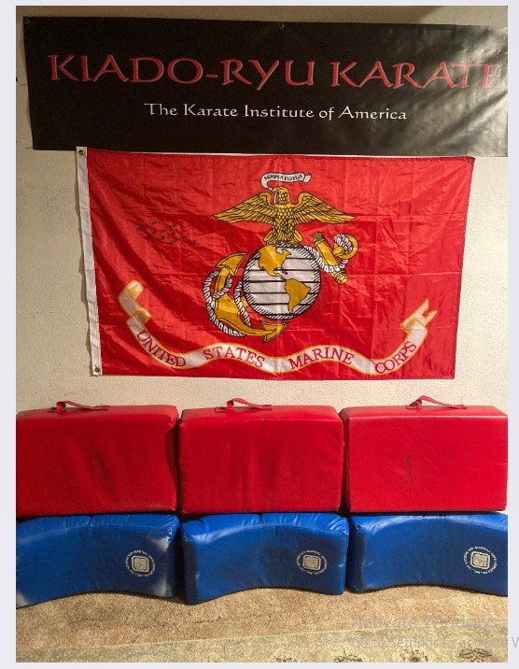

Also, what a great note below, Will! Semper Fi to you, too, young man, and we pray for your safety wherever and whenever you are stationed!

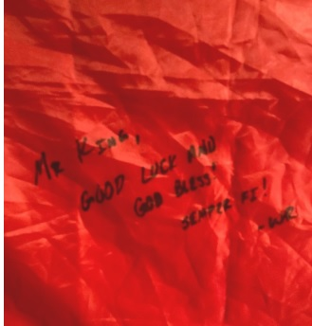

And, of course, CONGRATULATIONS again to you, Skull! You are an inspiration to all and we look forward to enjoying your ascent to Black Belt and beyond!

[pic below]

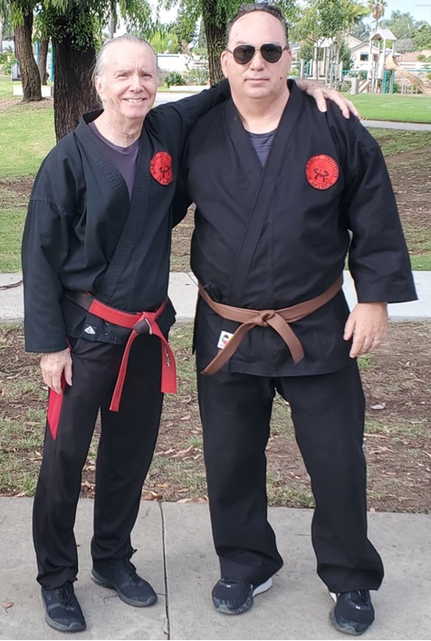

~finis

© Richard Andrew King, the Karate Institute of America(tm) and Kiado-Ryu(tm) Martial Arts.

