ANATOMY OF A KNOCKOUT

HOLLY HOLM vs ALLANNA JONES
https://www.youtube.com/watch?v=kCAM04TaZQg

KNOCKOUT! It’s the primary goal and success of any fighter—a trophy for the victor’s wall.

Knockouts don’t generally occur by luck. They are more often the result of design and opportunity. This KIA feature addresses the “Anatomy of a Knockout” when Allanna Jones was kayoed by Holly Holm.

The intent of this assessment is not to disparage Allanna Jones but, rather, to be informative as to how not to get knocked out.

In the photo below both fighters are balanced, which is excellent. That’s about to change.



Now a shift occurs. Jones leans back on her right leg; her left leg lifts off the mat; her shoulders generate an imbalanced position over her hips. She’s stuck in place. This posture is a death knell.



In that moment of imbalance, Holm delivers a roundhouse kick to Jones’ right head/neck area. Bang! Knockout! Jones falls to the floor.



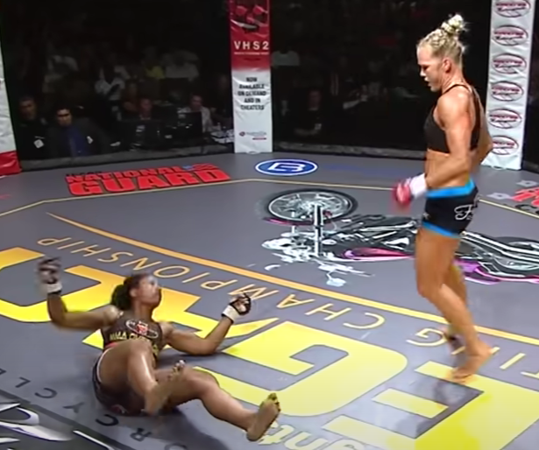

As she lies on her back unconscious and defeated, Jones’ staff attend to her. Luckily, she’s okay.



The following four-pic screen cap shows the knockout.

Screen cap #1—top left: Jones leans back on one leg to escape from Holm’s punch. Notice Jones’ posture. Her shoulders, head and hip go back on her weighted right leg. Plus, her right hand guard drops, leaving her head exposed. Jones’ balance is gone; her head’s exposed, her weight is restricted to her right leg. All of this is a cocktail for disaster.

Screen cap #2—lower left: Jones’ posture continues to dissolve while Holm begins her left roundhouse kick.

Screen cap #3—top right: Holm’s kick finds its mark for the knockout.

Screen cap #4—bottom right: Jones’ fight is over as she falls unconscious.

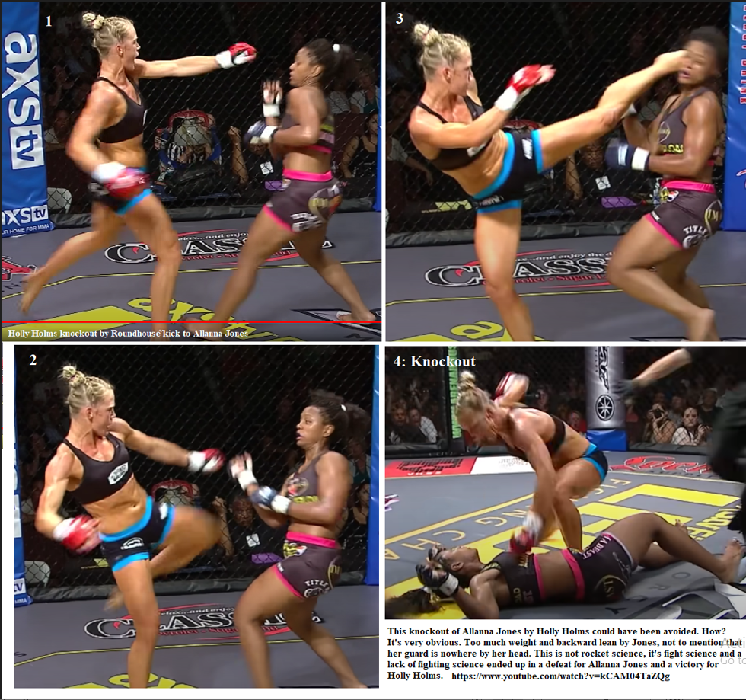

This knockout of Allana Jones by Holly Holm could have been avoided. How? It’s very obvious. There is too much weight and backward lean by Jones on her right leg, not to mention that her guard is nowhere by her head. A fighter cannot fight well in this posture. This is why Jones’ lost the fight. Her mechanics (footwork, guard and posture) were, frankly, horrible. Yet, Jones’ loss was not unusual. It’s pretty common, actually. Staying balanced, moving, and keeping one’s guard up to protect the head generate a recipe for not getting knocked out.

Fighting is not rocket science, it’s fight science, and a lack of fighting science is often the reason why people lose fights, even get kayoed. A lack of “Fight Science” is why Allanna Jones got knocked out and why Holly Holm won the contest. As the great Sun Tzu stated:

War is a grave concern of the state. It must be thorough studied.

Underscore thoroughly studied.

Great Champion

Holly Holm has a reputation for being a tough but humble fighter. When she wins, she doesn’t preen around pumping out her chest, claiming victory and acting like an adolescent pompous troglodyte who just killed his first worm. She is a rare breed of fighter and one who is to be admired. Although tough and successful, Holly Holm has grace—a quality present among all truly great champions.

~finis
© The Karate Institute of America(^{tm)}, Kiado-Ryu.com(^{tm)} and RichardKing.net(^{tm)}

