WIND GOES GREEN!

Thursday, 30 November 2023, was another auspicious day for Shaw “Wind” " Shahriari as he easily passed his Green Belt test (with a little stress). Congratulations, young man!

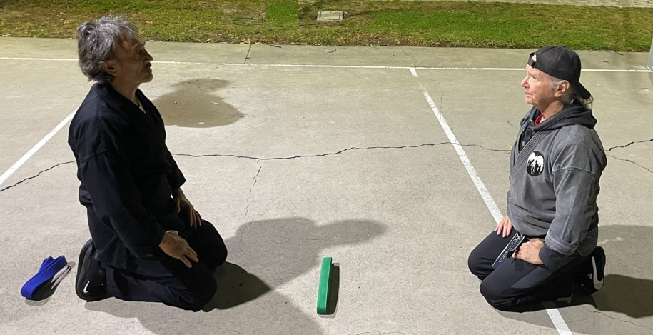

A fruitful—and joyous—accomplishment. “Great job, Wind!”
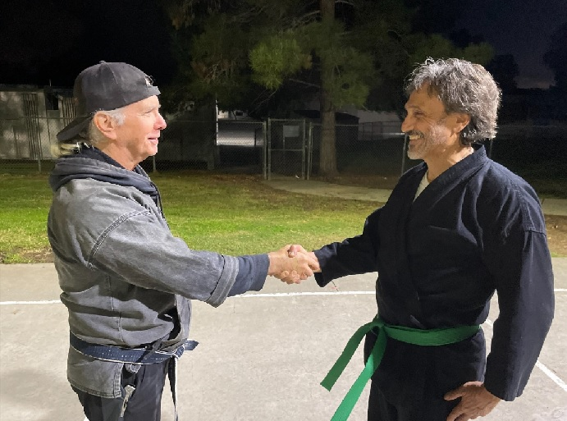

Adding to the auspicious occasion was the presence of Kiado-Ryu Green Belt Aidan “Smasher” Ligtvoet—a once precocious young lad who has blossomed into a giant young man, now 17 years of age and a Senior in High School. Smasher will be testing for First Brown Belt soon.

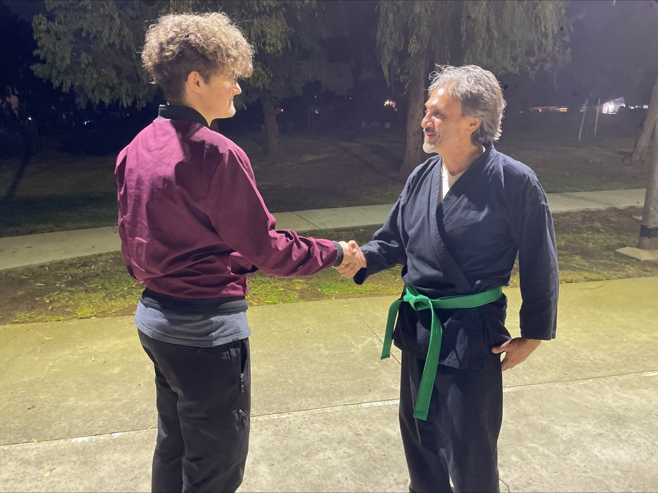

For reference, Shaw is approximately 5’8”! Smasher . . . hardly! Remember this kid? Priceless!


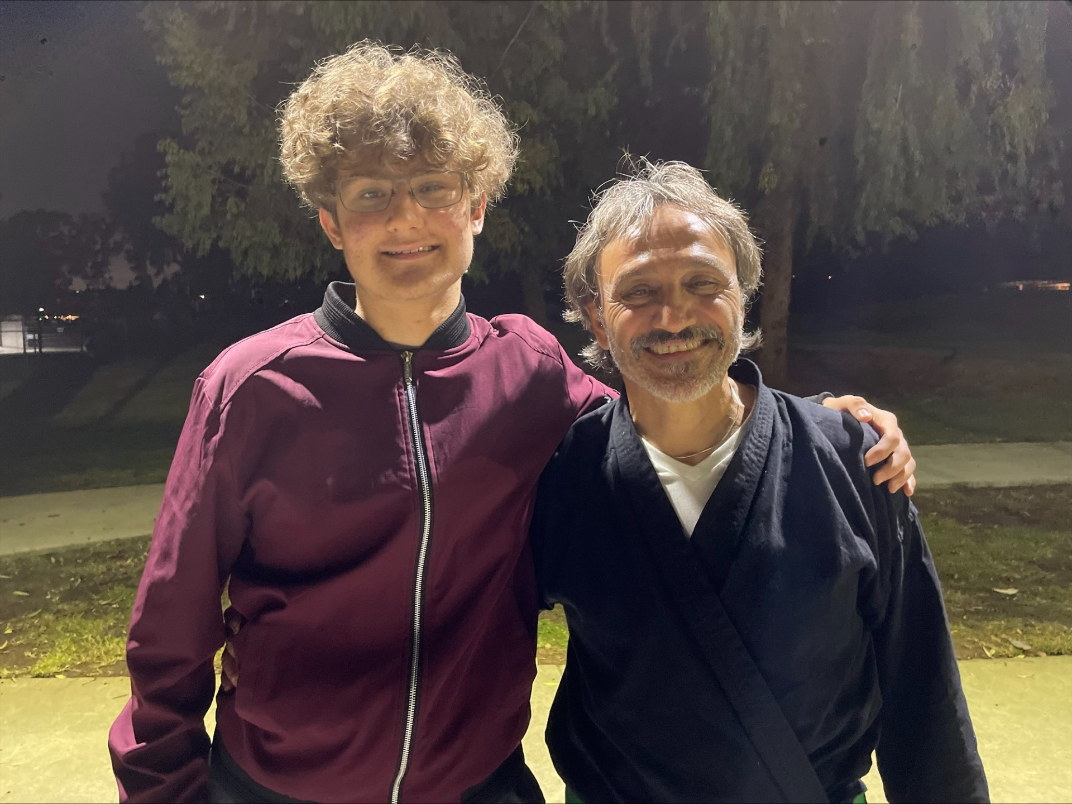

Brothers in arms in their pursuit of a Kiado-Ryu Black Belt. Great smiles! Great men!

Wind and Smasher are excellent examples of what it is to be a martial artist. They’re both tough but also kind-hearted and . . . they are terrific fighters. Not every martial artist is a great fighter but these two are, definitely.

Thank you, gentlemen, for your outstanding work, devotion, character and skill. It’s fun watching you both mature and excel. The Karate Institute of America and the Kiado-Ryu system of martial arts are blessed to have you as our own. We excitedly look forward to your next step in the process of climbing the KIA ladder. You are both an inspiration to others, exemplifying what can be done when one puts in the hard work and determination! Carry on, gentlemen! The next rung on the ladder awaits you!

© Richard Andrew King and Kiado-Ryu Martial Arts.

