SHAKESPEARE & MARTIAL ARTS

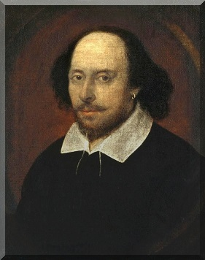

WILLIAM SHAKESPEARE is, arguably, the greatest writer in history. He is certainly the greatest playwright the world has ever known. Who is there who has never heard of the Great Bard, read one of his plays, his poems, his sonnets or recited one of his quotations?

But what in the world has Shakespeare got to do with Martial Arts, you might ask? After all, he was a writer, not a fighter.

First, Shakespeare was an artist but so also are martial artists. Artistry is diverse.

Second, Shakespeare was a realist. He understood life—its ups and downs, its joys and sorrows, its comedies and tragedies. Every martial artist can also opine on these oppositional aspects of life, such as victory and defeat, success and failure, good moments and bad.

The wisdom in Shakespeare’s writings is profound because it covers the entire breadth of human experience.

In today’s socially active age, for instance, young people often try to be like someone else, but trying to be like someone else is a dead-end road. In Shakespeare’s famous play, Hamlet—Act 1, scene 3, the Great Bard comments on this truth through the character of Polonius—a father who is giving advice to his son, Laertes, who is moving out of the house, so to speak, and beginning his journey into manhood. Polonius counsels his son . . .

This above all--to thine own self be true, and it must follow,
as the night the day, thou canst not then be false to any man.

In simple words he is saying, “Don’t try to be like someone else because you’re not someone else. You are you. Honor that. Therefore, you be you and let them be them.”

Martial arts intrinsically teaches us to be us, not to be someone else or even attempt to be like someone else. When we spar, for example, no one is taking our place. We do the fighting, not a stand in. It’s the same with performing a kata—we perform it, not someone else. There’s no way to get around this simple reality. For the most part, martial arts teaches us to be genuine, not phony. Phony people are never content or real. How could they ever be true to others when they can’t even be true to themselves? There are phony people in martial arts but the focus of the Karate Institute of America and the Kiado-Ryu system of martial arts is to seek and live on “high ground,” on elevated ethics and character. This is the same thing Polonius was telling Laertes. Be true to yourself. Don’t be false to people; to “any man.”

To be a whole individual we must be true to ourselves. This message is especially important for young people to understand, or even adults who want to be someone else, which is impossible. Attempting to be like someone else is denying our own preciousness. Everyone is a gift from God. So, be content with who you are. You be you and let them be them. That is real life. Honor it.

~finis

© Richard Andrew King, Kiado-Ryu Martial Arts and the Karate Institute of America.

