SAMURAI REVIEW
The Four Factors

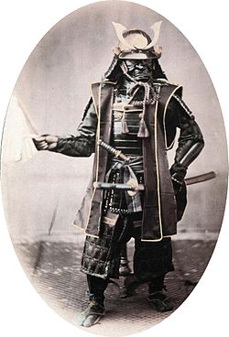
Photo courtesy of Wikipedia

During their time, the Japanese samurai were some of the most fierce and fearful warriors on the planet. One of their constant warcraft strategies consisted of four prime attributes—skill, courage, movement and eyesight.

Regarding these four precepts of fighting, there was an order of efficiency. How would you rate the following four fighting principles of skill, courage, movement and eyesight in order of importance—from top to bottom? Think you know the answer? Let’s see.

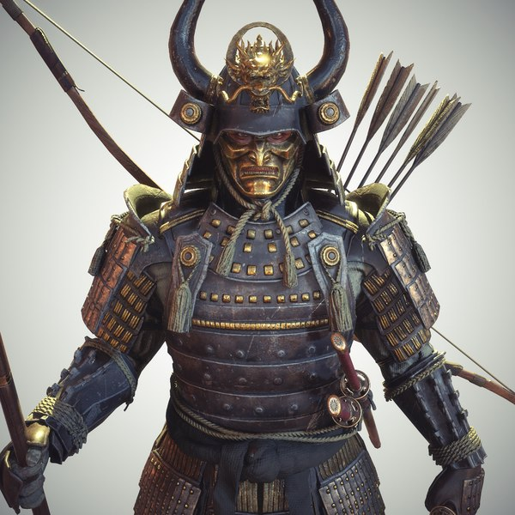
Photo courtesy of https://theprodigyofideas.wordpress.com/2022/02/02/samurai/

#1. Eyesight. As simple as it is, eyesight is often missed as the most important fighting principle. Why? If a warrior can’t see, he simply can’t fight, at lease not well and certainly not for long. Therefore, eyesight is the most important fighting facet. Close your eyes and see how vulnerable you are in a threatening circumstance. Being blind, you’re nothing more than a sitting duck whose demise is sooner than later, if not immediate.

#2. Movement: This is the most common miss of the four attributes. It seems innocuous but it’s not. As General George Patton stated, “Fixed fortifications are monuments to man's stupidity.”
Simply, a great warrior must be able to move—well and efficiently. Is it harder to hit a moving target than a stock-still one? We all know the answer. Therefore, move and keep moving. Nothing frustrates an opponent more than an adversary who won’t be still. And when a fighter gets frustrated, he starts losing his self-control, which can be to his demise. Very few fighters move at all, let alone well. That’s because they never practiced moving while fighting. If you want to be a great fighter, you’ve got to master the art of “movement.”

#3. Courage: This is often mistaken as the most important of the four aspects. A fighter has to be tough, strong and courageous, of course. However, a blind man who is standing still is just waiting to be defeated. He may have all the courage in the world but not be able to see or move, in which case he’s going to be a victim, not a victor.

#4. Skill: Ironically, skill is often chosen as the #1 fighting attribute. However, just because a warrior has skill doesn’t mean he is courageous. How many people with skill turn their backs and flee at the first sign of trouble? It’s one thing to act tough. It’s quite another to be tough. Actually, if you had a choice, it's far better to be tough than skilled. Skill stands for nothing unless it’s preceded by eyesight, movement and courage.

Did you also make note of the fact that these four factors of fighting—skill, courage, movement and eyesight—were placed backward in the first paragraph? Just checking.

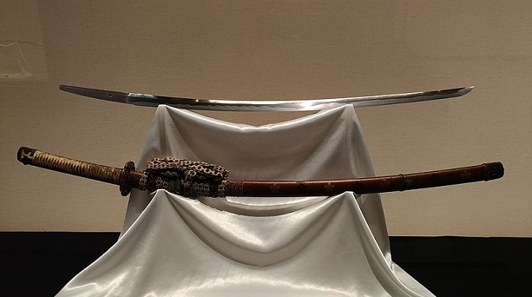
Photo courtesy of Wikipedia
~finis

© Richard Andrew King, Kiado-Ryu Martial Arts and the Karate Institute of America.

