FINLAND FIREARMS RISING
(Source – James Rothwell, “The Telegraph” 19 February 2024)
https://news.yahoo.com/finland-open-300-shooting-ranges-155200366.html

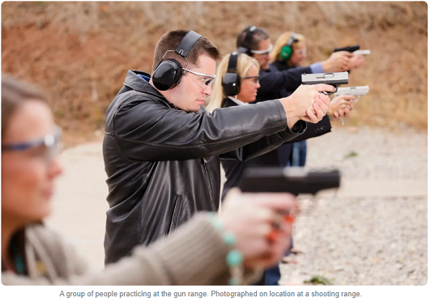

FIREARMS. Their primary use is for protection, plain and simple, as Finland has so clearly demonstrated by announcing its opening of 300 shooting ranges to expand their capability of national defense with a goal of 1,000 ranges by the end of the decade.

Why is this happening? Thank Vladimir Putin and his demented phobia of needless murdering in a desire to destroy Ukraine and its people. It’s madness. Yet, it’s also reality. Putin is an evil man who, like so many other demonic dictators throughout world history, is consumed with blood lust, power and domination.

Finns understand the relationship between guns, self protection and survival—a refreshing, clear-minded thought—when less aware people in other countries continue to denounce the common sense reality of safety and security that firearms generate.

Finns also require every male between 18 and 60 to serve in their army at some point. Now, there’s a novel idea for other countries to adopt. After all, why should any citizen not serve his/her country? And why not begin with the 18 year old children of congressional men and women? Every person who benefits from a country should serve that country at some time in their life. After all, it’s their country. They need to protect it.

The bottom line for all of us is . . . it’s our life and we need to protect it and if we don’t protect it, we have no one to blame but ourselves if things go south, or worse. If we ever make it to heaven, we can discard our firearm(s), but until then it’s fight or be enslaved by those nefarious people who have the power via their weapons to enslave us, destroying our dignity, freedom, liberty and way of life.

Thanks, Finland! Keep up the courageous and common sense ideology of self protection using firearms. Your example is inspiring and worthy of note.

Read the entire article here: https://news.yahoo.com/finland-open-300-shooting-ranges-155200366.html

~finis
© Richard Andrew King, the Karate Institute of America, and Kiado-Ryu Martial Arts.

