Blast From the Past: Part 3

JASON “J.B.” BROWN

KIA Black Belt # 15

(December 15th 1990)

Jason “J.B.” Brown is the 15th Black Belt of the Kiado-Ryu’s current 65 Black Belts. Interestingly, he received his Black Belt on 15 December 1990, Lake Forest, Southern
California.

J.B. came up through the KIA Juniors Program and was one of the finest young fighters at the Karate Institute of America.

Jason has had quite a life. He’s traveled to 68 countries! In response to our query, he shared some of his life’s journey. Following are his own words.

Well, I’ve been in Germany 21 years now, and after 20 years of being a freelance university lecturer, mostly teaching on American media, I studied again to change careers and now work in software development on the psychological, motivational and organizational side of it. I had my first paid holiday in over 20 years when I went home over Christmas. The last 25 years I’ve been a travel addict— 68 countries and counting. I’ve written 5 novels and a play and had about 30 photo exhibitions, even in more “exotic” places like Peru, Romania, Montenegro. I’m engaged to Sammy, a British woman I met here in Germany seven years ago. And most importantly, my folks, both 73, are alive, and pretty damn well—all things considered; living still in Lake Forest.

It was nice to see some pics from 35-40 years ago. Too bad I didn’t get in any of them. Still, some serious memories. Cheers from Germany!

Wow! J.B., that’s quite a story. Very impressive. Thanks for sharing. I think it’s pretty safe to say you are the most traveled KIA Black Belt in history and most likely will keep that title!

Following are a few photos of Jason and Sammy. The pics are from Venice, hiking in eastern France, Oktoberfest and also Olvera Street in LA! Enjoy!

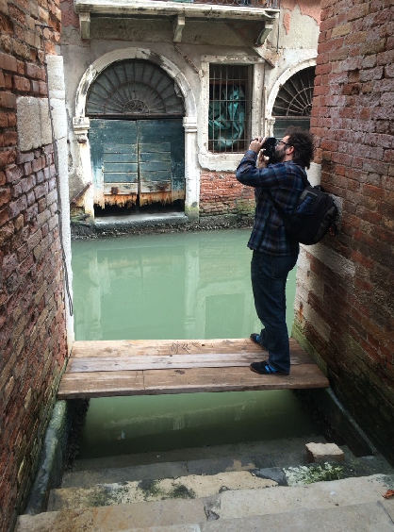
What an interesting and revealing photo of aging Venice!
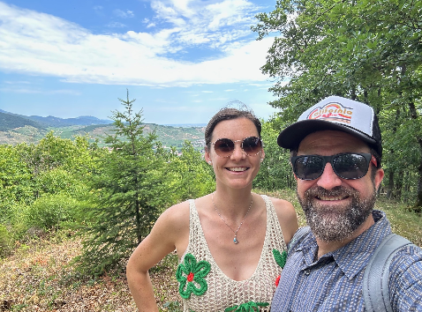
Marvelous scenery!
.
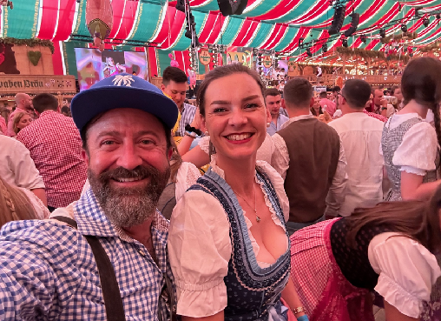
How fun . . . and such smiling faces, too!
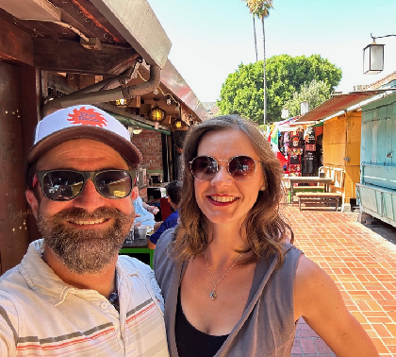
Happy couple! Nice photo of you two.

These are wonderful photos. Thanks for sharing them, J.B. We at the Karate Institute of America wish you and Sammy a healthy, prosperous and memorable future!

~finis

© Richard Andrew King, the Karate Institute of America and Kiado-Ryu Martial Arts.

